NAME : S.PADMAJA
REG NO: 192424159
16-06-2026
EXP 21.Write a Pandas program to swap the cases of a specified character column
in a given Data Frame.
AIM: To create a Data Frame using Pandas and swap the uppercase and lowercase letters of a specified character column.
ALGORITHM :
- Import the Pandas library.
- Create a DataFrame containing character data.
- Display the original DataFrame.
- Select the required column.
- Apply the swapcase() function using str.swapcase().
- Store the modified values back into the column.
- Display the updated DataFrame.
- End the program.
PYTHON CODE :
import pandas as pd

# Create DataFrame
df = pd.DataFrame({
'Name': ['Arun', 'Priya', 'KARTHIK', 'DiVyA'],
'Department': ['CSE', 'IT', 'ECE', 'AI']
})

print("Original DataFrame:")
print(df)

# Swap case of Name column
df['Name'] = df['Name'].str.swapcase()

print("\nDataFrame after swapping case:")
print(df)
OUTPUT :
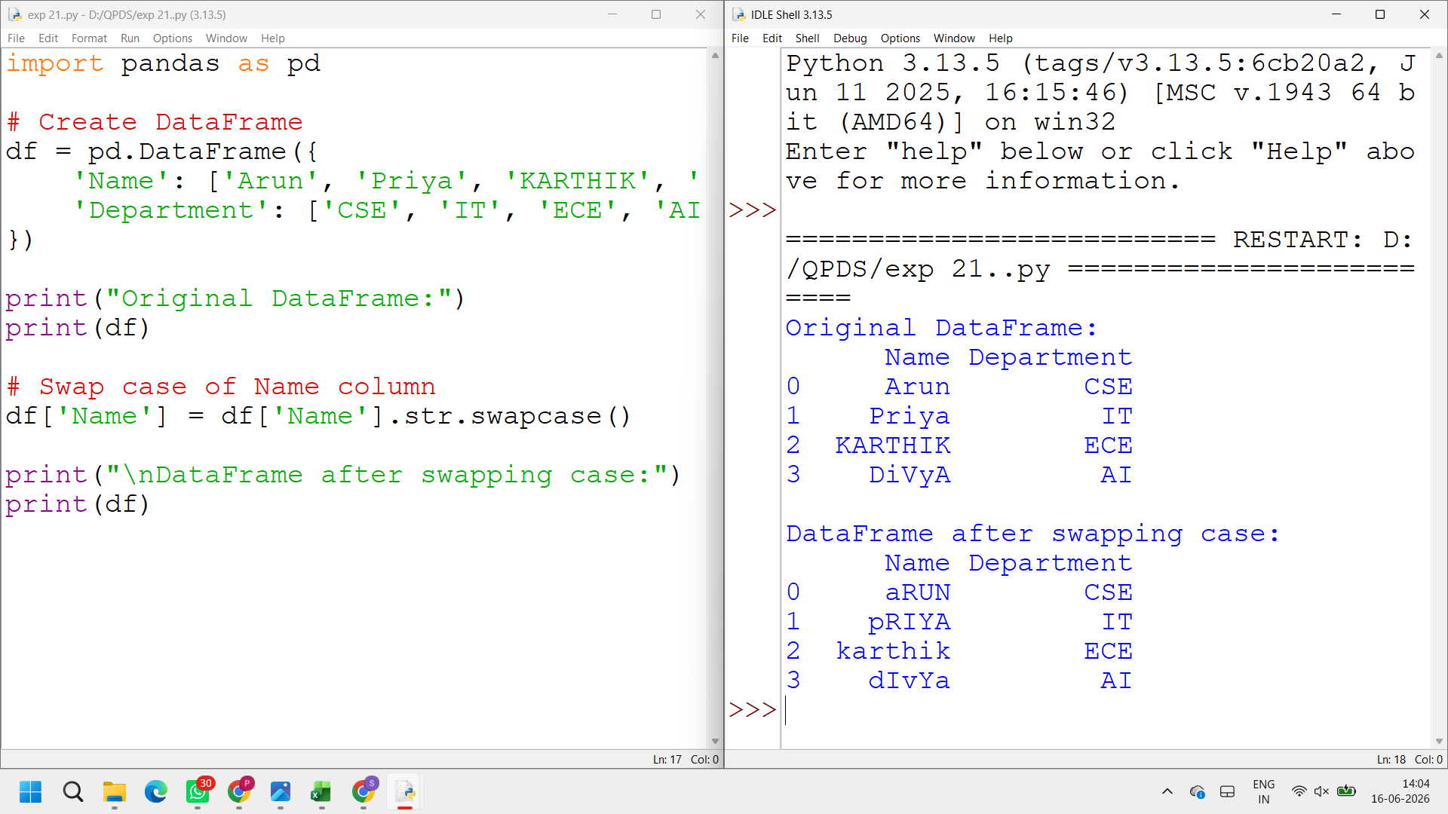

EXPERIMENT 22 :
AIM : To draw a line graph using Matplotlib with appropriate labels for the X-axis, Y-axis, and a title.
ALGORITHM :
• Import the Matplotlib library.
• Define values for the X-axis and Y-axis.
• Use the plot() function to draw the line.
• Add a label for the X-axis using xlabel().
• Add a label for the Y-axis using ylabel().
• Add a title using title().
• Display the graph using show().
• End the program.
PYTHON CODE :
import matplotlib.pyplot as plt

x = [1, 2, 3, 4, 5]
y = [2, 4, 6, 8, 10]

plt.plot(x, y)

plt.xlabel("X Axis")
plt.ylabel("Y Axis")
plt.title("Simple Line Graph")

plt.show()
OUTPUT :
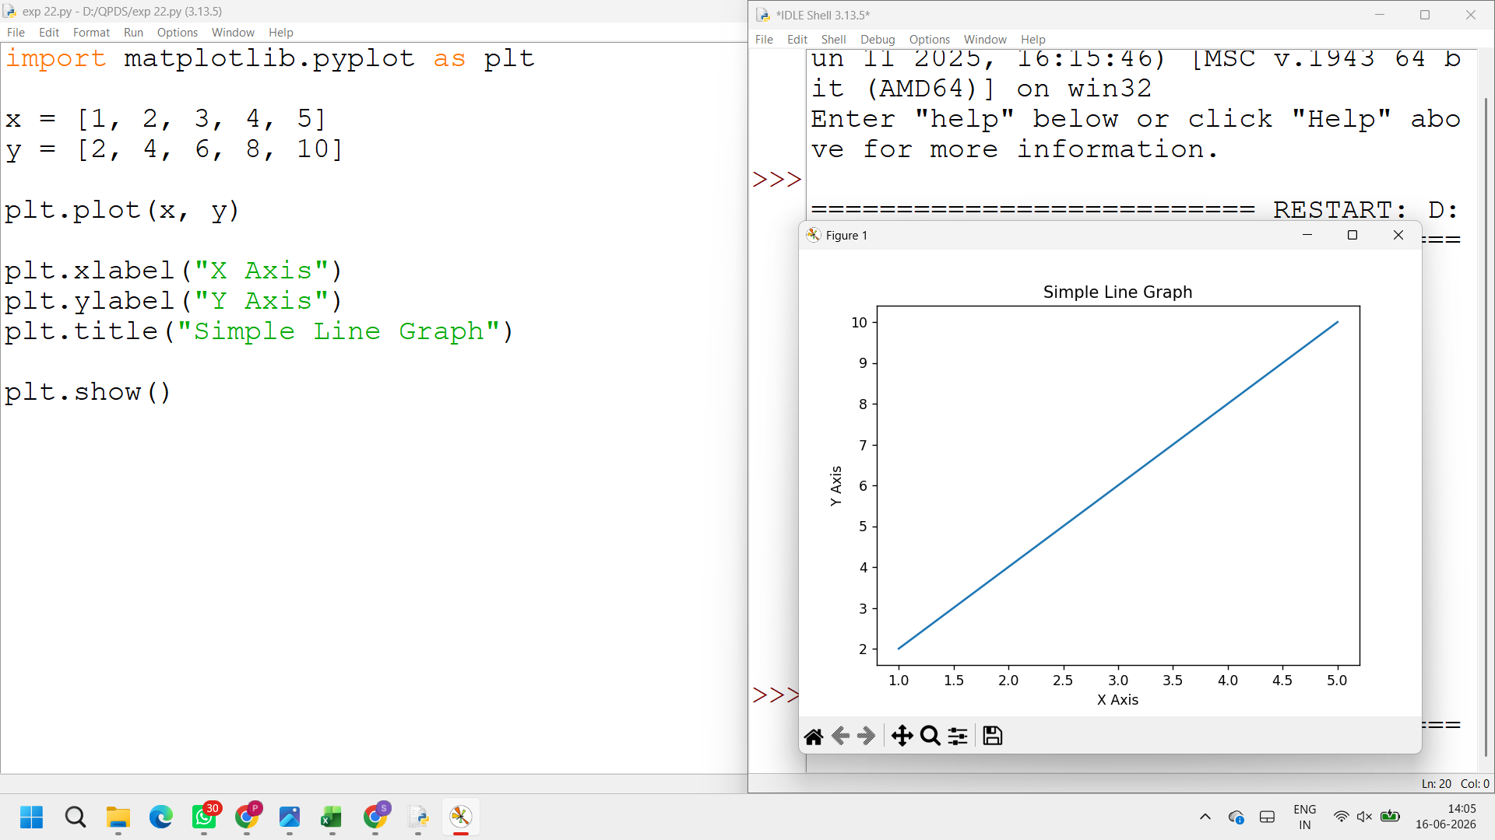

EXPERIMENT 23:
AIM : To read axis values from a text file and draw a line graph with suitable axis labels and title.
Algorithm
- Import the Matplotlib library.
- Create empty lists for X and Y values.
- Open the text file in read mode.
- Read each line from the file.
- Split the line into X and Y values.
- Store the values in separate lists.
- Use the plot() function to draw the graph.
- Add labels for the X-axis and Y-axis.
- Add a suitable title to the graph.
- Display the graph using show().
- End the program.

PYTHON CODE :
import matplotlib.pyplot as plt

x = []
y = []

with open("test.txt", "r") as file:
for line in file:
a, b = line.split()
x.append(int(a))
y.append(int(b))

plt.plot(x, y)

plt.xlabel("X Axis")
plt.ylabel("Y Axis")
plt.title("Line Graph from Text File")

plt.show()
OUTPUT :

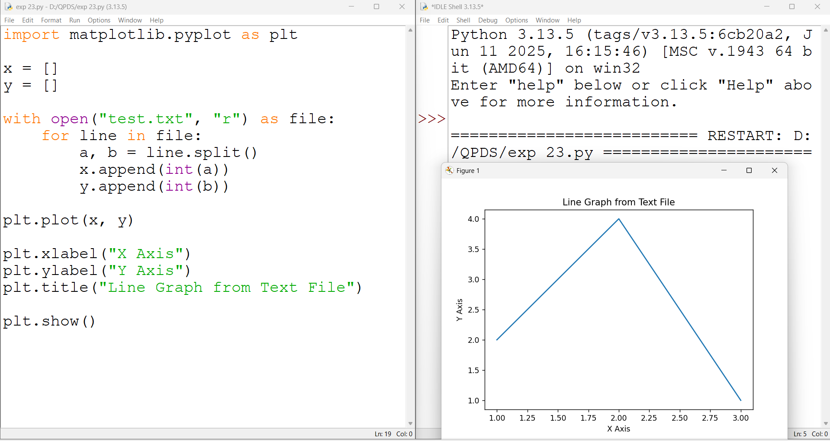

17-06-2026
EXPERIMENT 24:
AIM : To create a line chart for the financial data of Alphabet Inc. from October 3, 2016 to October 7, 2016 using Python and Matplotlib.
Algorithm
- Import pandas and matplotlib libraries.
- Read the CSV file containing financial data.
- Extract Date, Open, High, Low, and Close columns.
- Plot the values against Date.
- Add title, labels, legend, and grid.
- Display the chart.
Python code :
import pandas as pd
import matplotlib.pyplot as plt

data = pd.read_csv("fdata.csv")

plt.plot(data['Date'], data['Open'], label='Open')
plt.plot(data['Date'], data['High'], label='High')
plt.plot(data['Date'], data['Low'], label='Low')
plt.plot(data['Date'], data['Close'], label='Close')

plt.title("Alphabet Inc Financial Data")
plt.xlabel("Date")
plt.ylabel("Price")
plt.legend()
plt.grid(True)

plt.show()
Output :
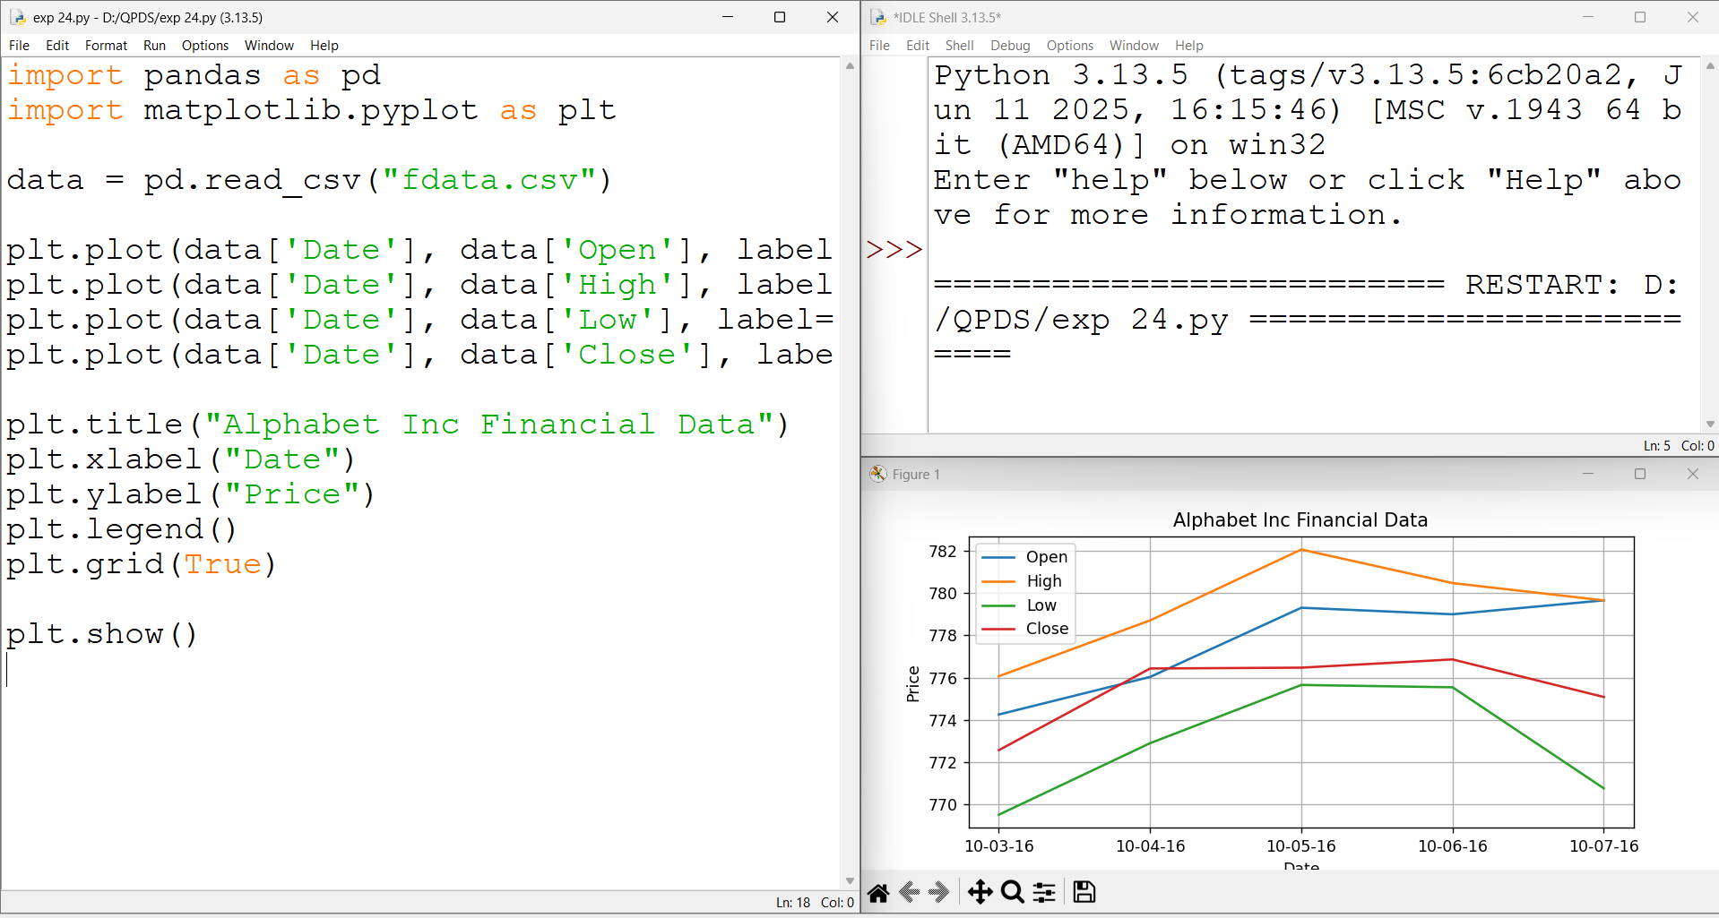

EXPERIMENT 25 :
AIM: To plot multiple lines with different colors, widths, and legends using Matplotlib.
Algorithm
- Import matplotlib.
- Create x-axis and y-axis data.
- Plot multiple lines with different colors and linewidths.
- Add legend, title, and labels.
- Display the graph.
Python code :
import matplotlib.pyplot as plt

x = [1, 2, 3, 4, 5]

y1 = [10, 20, 30, 40, 50]
y2 = [15, 25, 35, 45, 55]

plt.plot(x, y1, color='red', linewidth=2,
label='Line 1')

plt.plot(x, y2, color='blue', linewidth=4,
label='Line 2')

plt.title("Multiple Lines with Legends")
plt.xlabel("X-axis")
plt.ylabel("Y-axis")

plt.legend()
plt.grid(True)

plt.show()
Output :
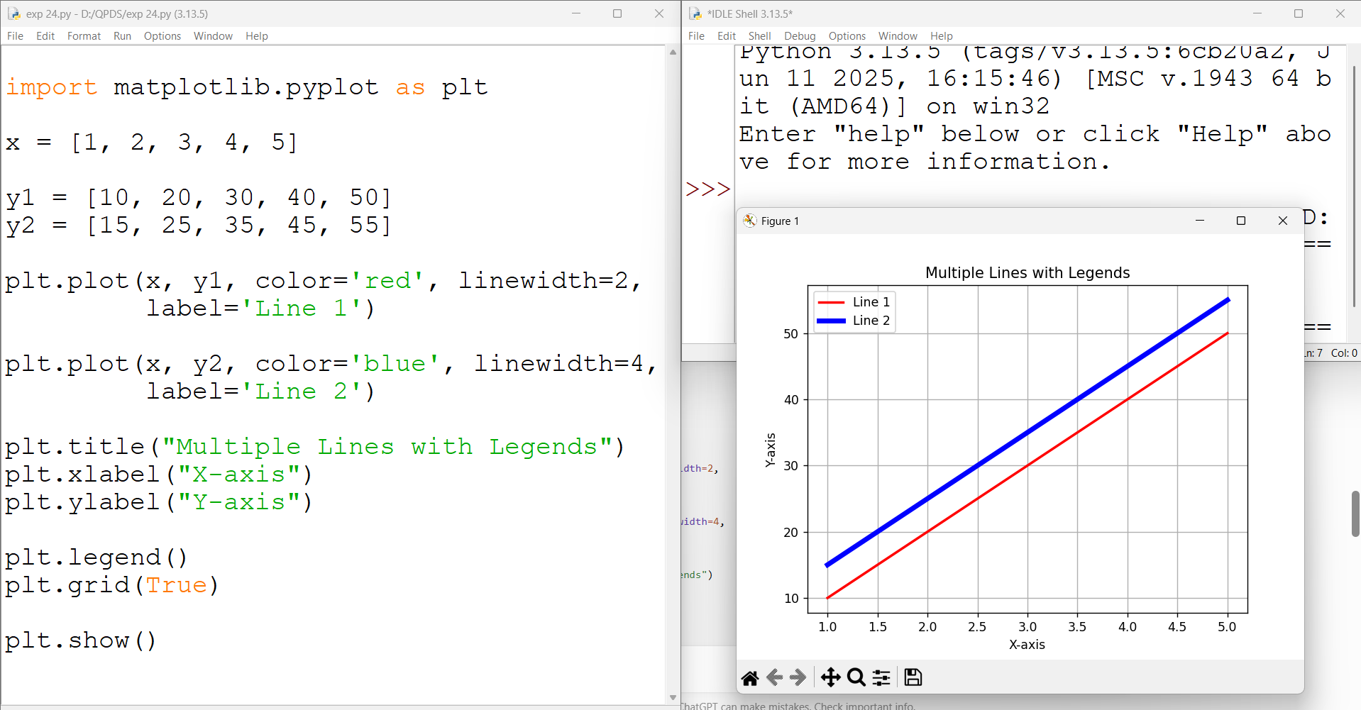

EXPERIMENT 26 :
AIM : To create multiple plots in a single figure using Matplotlib.
Algorithm :
- Import matplotlib.
- Create sample data.
- Use subplot() to create multiple plots.
- Plot different graphs in each subplot.
- Add titles and labels.
- Display the figure.

PYTHON CODE :
import matplotlib.pyplot as plt

x = [1, 2, 3, 4, 5]
y1 = [1, 4, 9, 16, 25]
y2 = [1, 2, 3, 4, 5]

plt.subplot(2, 1, 1)
plt.plot(x, y1)
plt.title("Square Numbers")
plt.subplot(2, 1, 2)
plt.plot(x, y2)
plt.title("Natural Numbers")
plt.tight_layout()
plt.show()
OUTPUT:
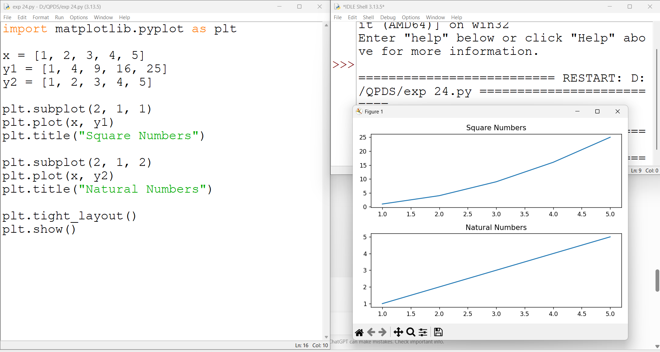
18-06-2026
EXPERIMENT 27 :
AIM : To create a bar chart showing the popularity of different programming languages using Python and Matplotlib.
Algorithm :
- Import the Matplotlib library.
- Create a list of programming languages.
- Create a list of their popularity percentages.
- Use the bar() function to create a bar chart.
- Add title and axis labels.
- Display the chart.
Python code :
import matplotlib.pyplot as plt

languages = ['Java', 'Python', 'PHP',
'JavaScript', 'C#', 'C++']

popularity = [22.2, 17.6, 8.8, 8.0, 7.7, 6.7]

plt.bar(languages, popularity)

plt.title("Popularity of Programming Languages")
plt.xlabel("Programming Languages")
plt.ylabel("Popularity (%)")

plt.show()
OUTPUT :
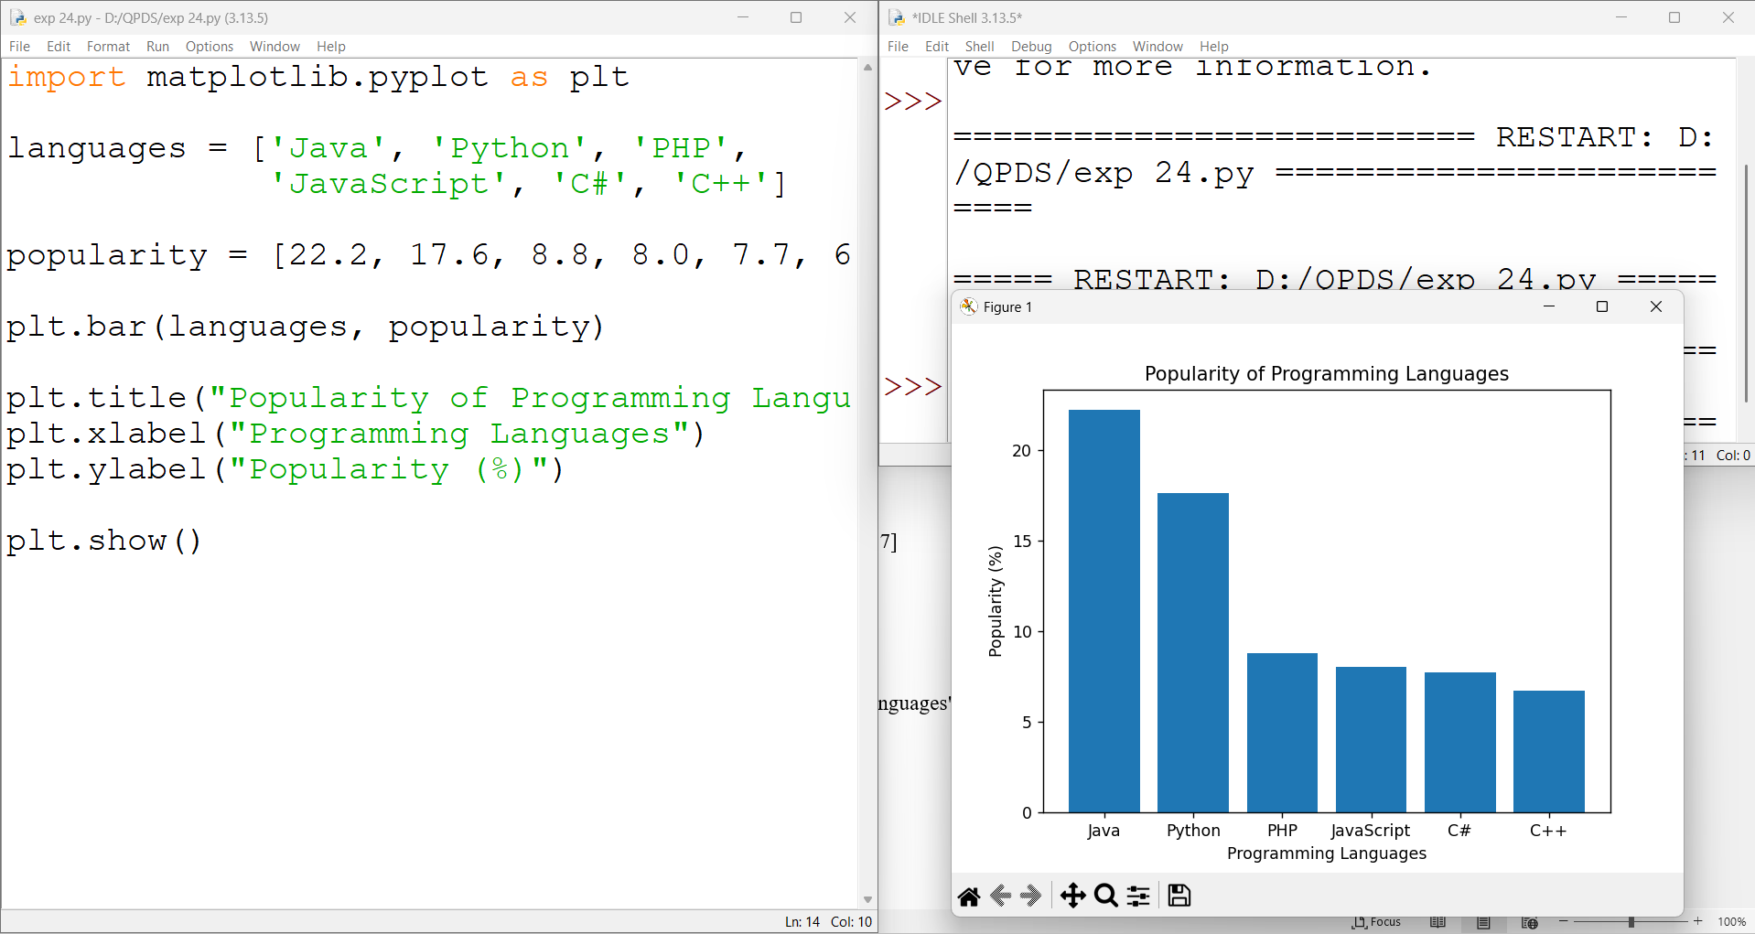

18-06-2026
EXPERIMENT 28:
AIM: To create a horizontal bar chart showing the popularity of different programming languages using Matplotlib.
Algorithm
- Import the Matplotlib library.
- Create two lists: programming languages and their popularity.
- Use barh() to create a horizontal bar chart.
- Add title and axis labels.
- Display the chart.
PYTHON CODE :
import matplotlib.pyplot as plt

languages = ['Java', 'Python', 'PHP', 'JavaScript', 'C#', 'C++']
popularity = [22.2, 17.6, 8.8, 8.0, 7.7, 6.7]

plt.barh(languages, popularity)

plt.xlabel("Popularity")
plt.ylabel("Programming Languages")
plt.title("Popularity of Programming Languages")

plt.show()
OUTPUT :
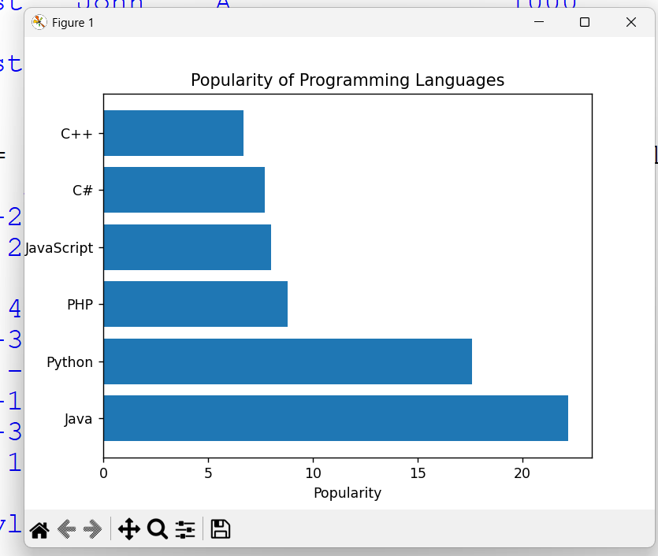

EXPERIMENT 29:
AIM : To create a bar chart showing the popularity of programming languages using different colors for each bar.
Algorithm
- Import Matplotlib.
- Create lists for languages and popularity values.
- Define a color for each bar.
- Use bar() to create the chart.
- Add labels and title.
- Display the chart.
PYTHON CODE:
import matplotlib.pyplot as plt

languages = ['Java', 'Python', 'PHP', 'JavaScript', 'C#', 'C++']
popularity = [22.2, 17.6, 8.8, 8.0, 7.7, 6.7]

colors = ['red', 'blue', 'green', 'orange', 'purple', 'brown']

plt.bar(languages, popularity, color=colors)

plt.xlabel("Programming Languages")
plt.ylabel("Popularity")
plt.title("Popularity of Programming Languages")

plt.show()
OUTPUT :
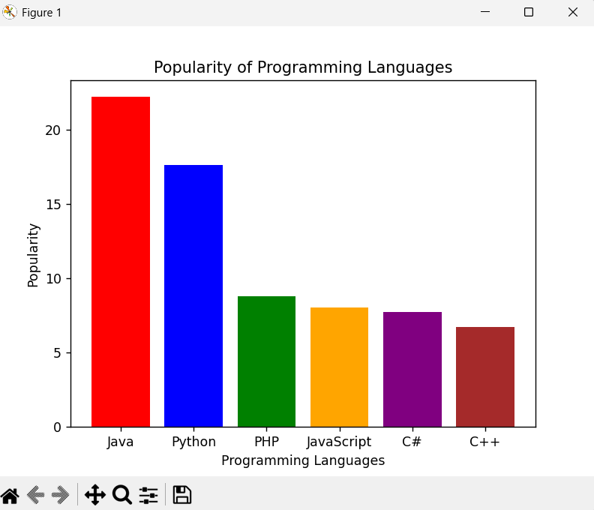

EXPERIMENT 30 :
AIM : To create a grouped bar chart comparing scores of men and women across different groups.
Algorithm
- Import NumPy and Matplotlib.
- Store men's and women's scores in separate lists.
- Create X-axis positions using NumPy.
- Plot bars for men and women side-by-side.
- Add labels, title, and legend.
- Display the chart.
PYTHON CODE :
import numpy as np
import matplotlib.pyplot as plt

men_means = (22, 30, 35, 35, 26)
women_means = (25, 32, 30, 35, 29)

groups = ['G1', 'G2', 'G3', 'G4', 'G5']

x = np.arange(len(groups))
width = 0.35

plt.bar(x - width/2, men_means, width, label='Men')
plt.bar(x + width/2, women_means, width, label='Women')

plt.xlabel("Groups")
plt.ylabel("Scores")
plt.title("Scores by Group and Gender")
plt.xticks(x, groups)
plt.legend()

plt.show()
OUTPUT :
